Geometric radius

Definition
# Source: AI Source: Provided by: [Data Path: Persons Table -> ID Column: 1, Name_En Column: Motasem Essam] -> From: [ChatGPT] on [7/25/2026]
The geometric radius of a sphere is the distance from the sphere’s center to any point on its surface. It is the fundamental length measurement that defines the size of a perfect sphere.
If $O$ is the center and $P$ is any point on the surface, the geometric radius is the length of the segment $OP$.
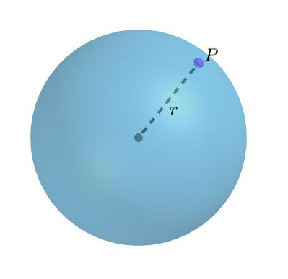
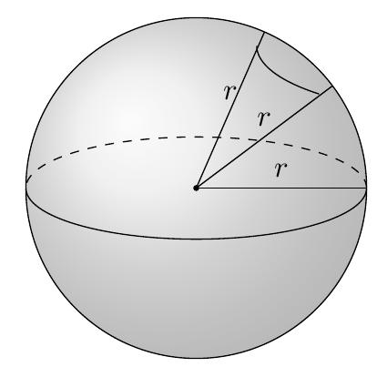
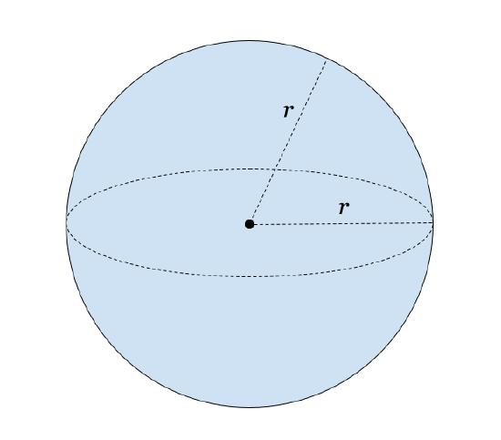

Simple Definition
# Source: AI Source: Provided by: [Data Path: Persons Table -> ID Column: 1, Name_En Column: Motasem Essam] -> From: [ChatGPT] on [7/25/2026]
The geometric radius is the distance from the center of a sphere to its outer surface.
- It is represented by $R$ or $r$.
- Every radius of the same sphere has equal length.
- It is half the sphere’s diameter.
- It determines the sphere’s surface area and volume.

Geometric Representation
# Source: AI Source: Provided by: [Data Path: Persons Table -> ID Column: 1, Name_En Column: Motasem Essam] -> From: [ChatGPT] on [7/25/2026]
Consider a sphere with center $O$, radius $R$, and surface points $A$, $B$, and $C$.
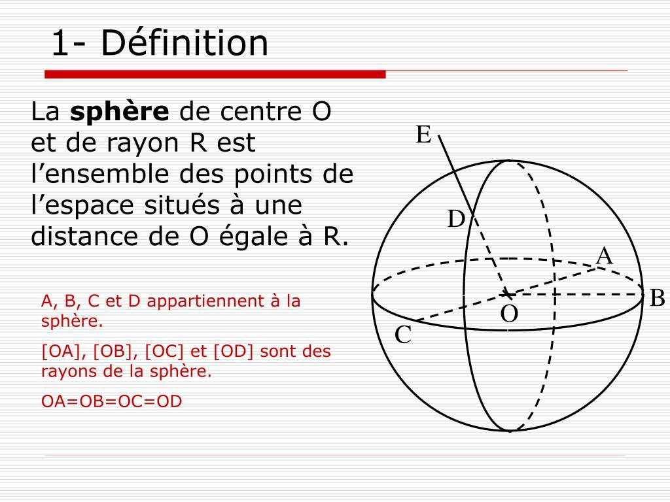
The radius segments satisfy:
$$OA=OB=OC=R$$
For any point $P$ on the sphere’s surface:
$$\boxed{OP=R}$$
The geometric radius is a length, not the area of a circular cross-section or the volume of the sphere.

Key Characteristics
# Source: AI Source: Provided by: [Data Path: Persons Table -> ID Column: 1, Name_En Column: Motasem Essam] -> From: [ChatGPT] on [7/25/2026]
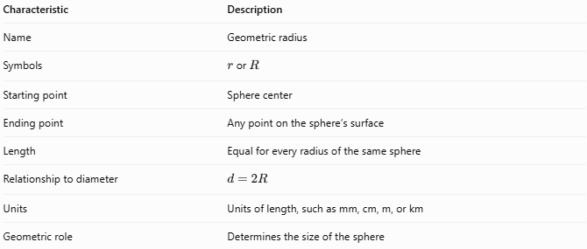
Characteristic | Description
Name | Geometric radius
Symbols | $r$ or $R$
Starting point | Sphere center
Ending point | Any point on the sphere’s surface
Length | Equal for every radius of the same sphere
Relationship to diameter | $$d=2R$$
Units | Units of length, such as mm, cm, m, or km
Geometric role | Determines the size of the sphere

Mathematical Formulas

Radius and diameter
# Source: AI Source: Provided by: [Data Path: Persons Table -> ID Column: 1, Name_En Column: Motasem Essam] -> From: [ChatGPT] on [7/25/2026]
$$\boxed{R=\frac{d}{2}}$$
where $d$ is the diameter.

Sphere surface area
# Source: AI Source: Provided by: [Data Path: Persons Table -> ID Column: 1, Name_En Column: Motasem Essam] -> From: [ChatGPT] on [7/25/2026]
$$A=4πR^{2}$$
Solving for the radius:
$$\boxed{R=\sqrt{\frac{A}{4π}}}$$

Sphere volume
# Source: AI Source: Provided by: [Data Path: Persons Table -> ID Column: 1, Name_En Column: Motasem Essam] -> From: [ChatGPT] on [7/25/2026]
$$V=\frac{4}{3}πR^{3}$$
Solving for the radius:
$$\boxed{R=\sqrt[3]{\frac{3V}{4π}}}$$

Standard sphere equation
# Source: AI Source: Provided by: [Data Path: Persons Table -> ID Column: 1, Name_En Column: Motasem Essam] -> From: [ChatGPT] on [7/25/2026]
For a sphere with center $O=\left(a,b,c\right)$:
$${\left(x-a\right)}^{2}+{\left(y-b\right)}^{2}+{\left(z-c\right)}^{2}=R^{2}$$
The positive square root of the right-hand-side constant gives the radius.

Worked Examples
# Source: AI Source: Provided by: [Data Path: Persons Table -> ID Column: 1, Name_En Column: Motasem Essam] -> From: [ChatGPT] on [7/25/2026]
Example 1 — Calculate the radius from the diameter
A sphere has a diameter of $20\text{ cm}$.
$$R=\frac{d}{2}=\frac{20}{2}$$
$$\boxed{R=10\text{ cm}}$$
Example 2 — Calculate the radius from the surface area
A sphere has a surface area of $144π{\text{ cm}}^{2}$.
$$\begin{aligned}4πR^{2}&=144π \\ R^{2}&=36 \\ R&=6\end{aligned}$$
$$\boxed{R=6\text{ cm}}$$
Example 3 — Calculate the radius from the volume
A sphere has a volume of $500π{\text{ cm}}^{3}$.
$$\begin{aligned}\frac{4}{3}{πR}^{3}&=500π \\ R^{3}&=375 \\ R&=\sqrt[3]{375}\end{aligned}$$
$$\boxed{R≈7.21\text{ cm}}$$

Geometric Radius vs. Related Concepts
# Source: AI Source: Provided by: [Data Path: Persons Table -> ID Column: 1, Name_En Column: Motasem Essam] -> From: [ChatGPT] on [7/25/2026]
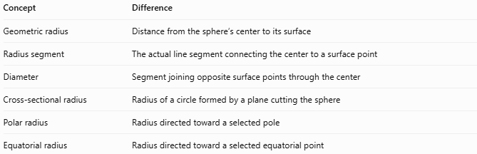
Concept | Difference
Geometric radius | Distance from the sphere’s center to its surface
Radius segment | The actual line segment connecting the center to a surface point
Diameter | Segment joining opposite surface points through the center
Cross-sectional radius | Radius of a circle formed by a plane cutting the sphere
Polar radius | Radius directed toward a selected pole
Equatorial radius | Radius directed toward a selected equatorial point
For a perfect sphere, the geometric, polar, and equatorial radii have the same length. A spheroid may have different polar and equatorial radii.

Applications
# Source: AI Source: Provided by: [Data Path: Persons Table -> ID Column: 1, Name_En Column: Motasem Essam] -> From: [ChatGPT] on [7/25/2026]
- Geometry: Calculating dimensions, surface areas, and volumes.
- Engineering: Designing spherical components, balls, and tanks.
- Astronomy: Measuring idealized spherical celestial bodies.
- Computer graphics: Defining sphere dimensions in three-dimensional models.
- Manufacturing: Checking the dimensions of spherical objects.

Key Points
# Source: AI Source: Provided by: [Data Path: Persons Table -> ID Column: 1, Name_En Column: Motasem Essam] -> From: [ChatGPT] on [7/25/2026]
- The geometric radius measures the distance from the center to the surface.
- Every radius of a perfect sphere has the same length.
- The diameter equals twice the radius.
- Surface area depends on the square of the radius.
- Volume depends on the cube of the radius.
- The geometric radius is distinct from the radius of a smaller circular cross-section.

Conclusion
# Source: AI Source: Provided by: [Data Path: Persons Table -> ID Column: 1, Name_En Column: Motasem Essam] -> From: [ChatGPT] on [7/25/2026]
The geometric radius is the fundamental length that defines a sphere’s size. It connects the sphere’s center to its surface and provides the basis for calculating its diameter, surface area, volume, and other geometric properties.

